1. Define properties in application.yml

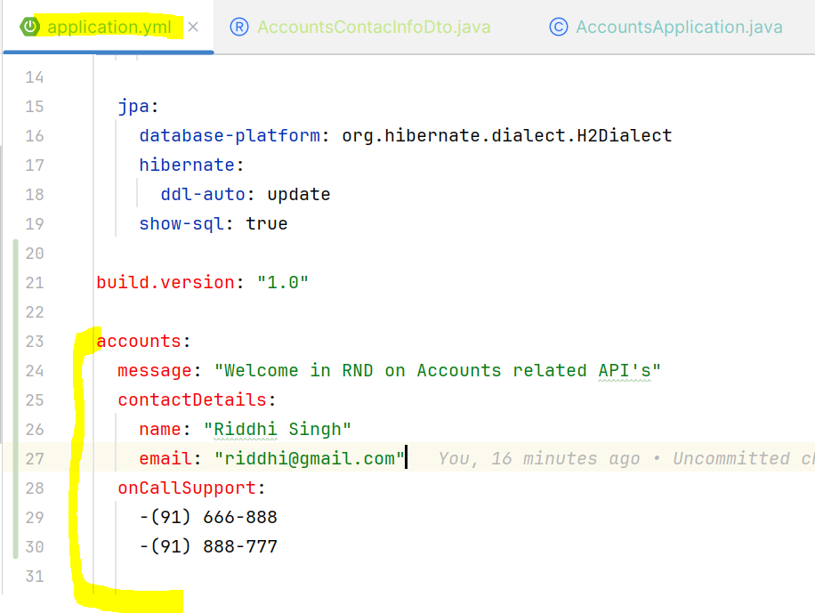

**2. Create a record class inside DTO package and name and type of the parameters should be same as defined inside application.yml and annotate the class with @ConfigurationProperties(prefix = "accounts") and prefix name should be same as the application properties header**

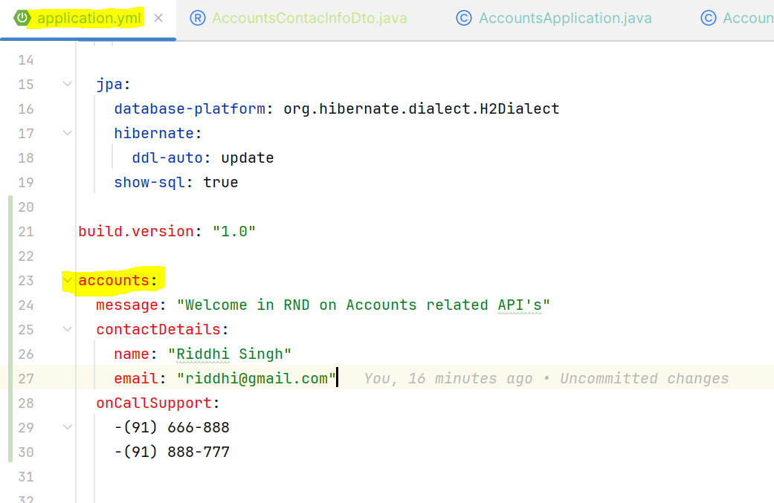

**3. Annotate the main class with @EnableConfigurationProperties(value = {AccountsContacInfoDto.class}) and pass the value as record class name**

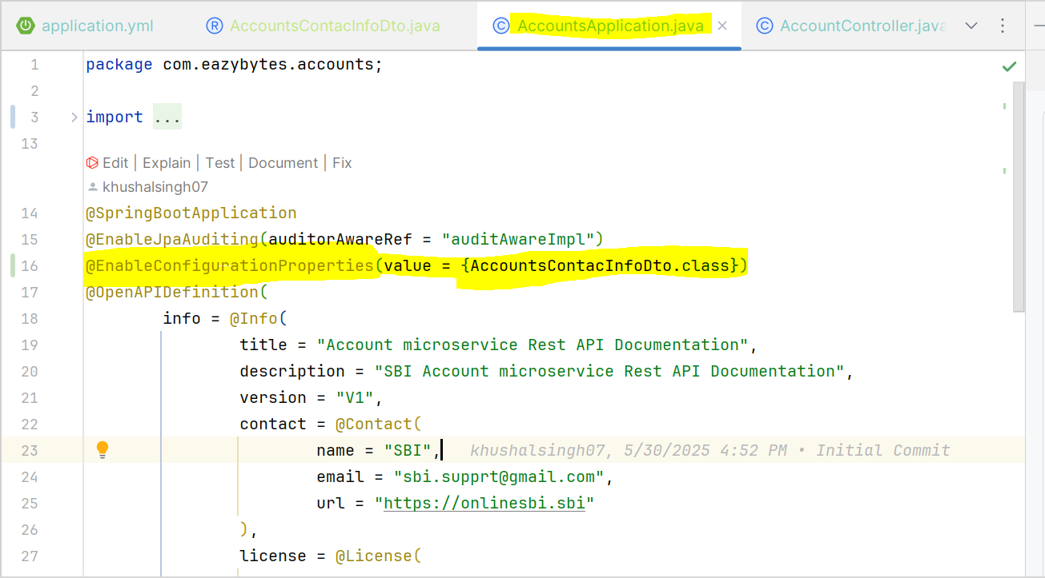

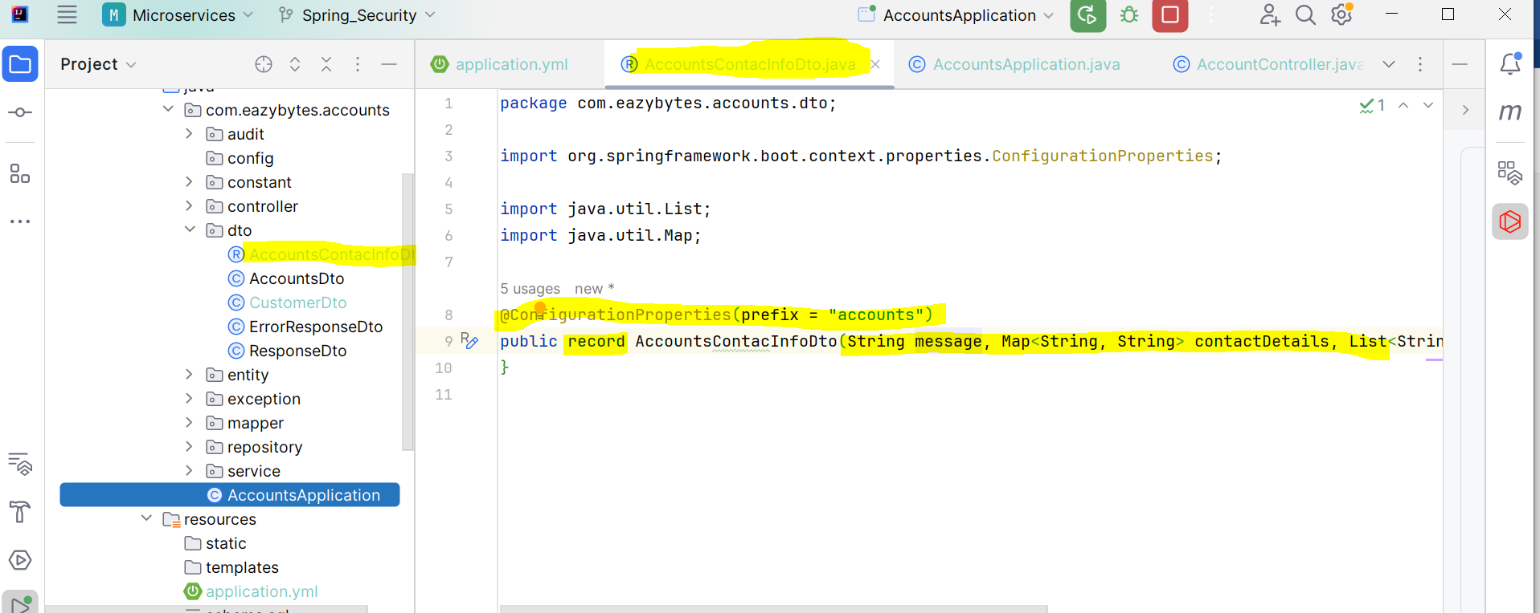

4. Calling method from Controller class

